**PRE-emergence herbicide selection for early planted soybeans**

Over the last two growing seasons (2020 and 2021), weather and soil conditions across southern Wisconsin were favorable for early soybean planting. Under suitable environmental conditions, planting early is a recommended strategy to increase the crop’s yield potential (See Dr. Conley’s blogpost: “Just the Facts Jack: Soybean Planting Date, Seeding Rate and Seed Treatment Recommendations” <https://coolbean.info/2021/04/11/just-facts-jack-soybean-planting-date-seeding-rate-seed-treatment-recommendations/>).

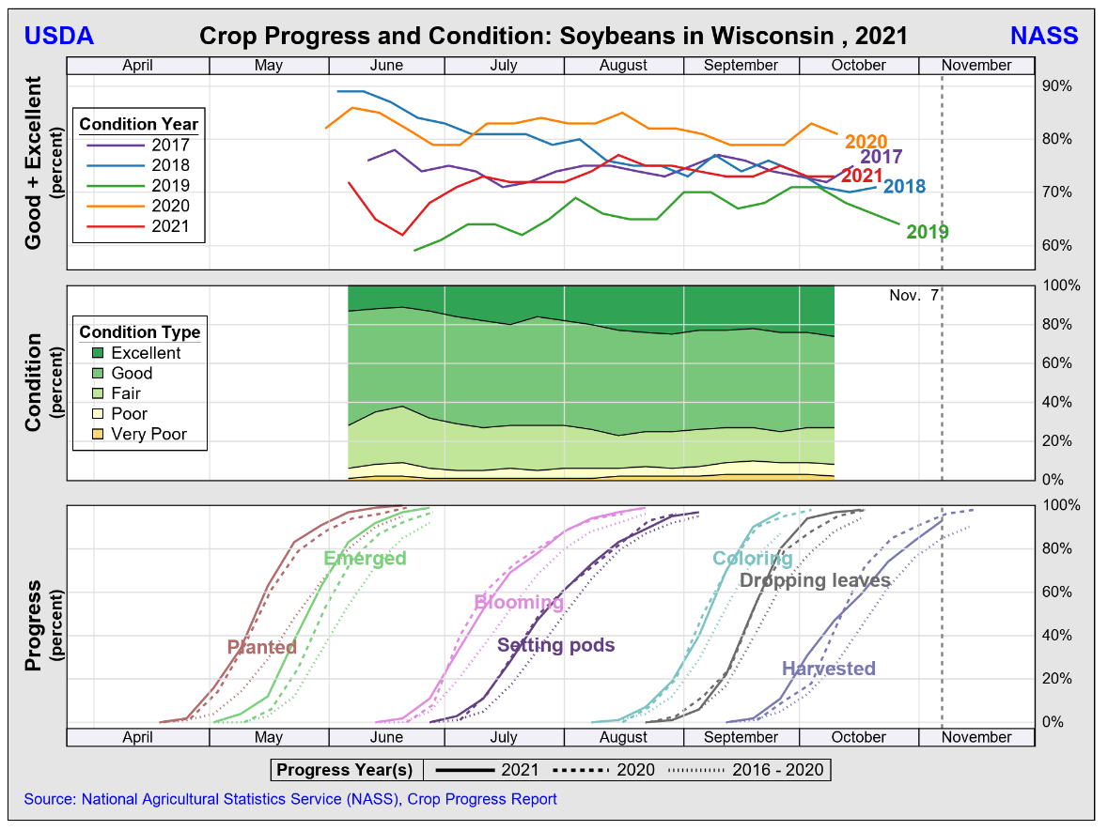

Source: <https://www.nass.usda.gov/Charts_and_Maps/Crop_Progress_&_Condition/2021/WI_2021.pdf>

In one of our studies led by the former Weed Science Graduate Student Nikola Arsenijevic conducted at Arlington Agricultural Research Station, near Arlington, WI in 2020, early planted soybeans (April 21, 2020) didn’t emerge until mid-May (May 15, 2020) whereas standard planted soybeans (May 22, 2020) emerged early June (June 01, 2020). The time from soybean planting to emergence is relevant for PRE-emergence herbicide selection.

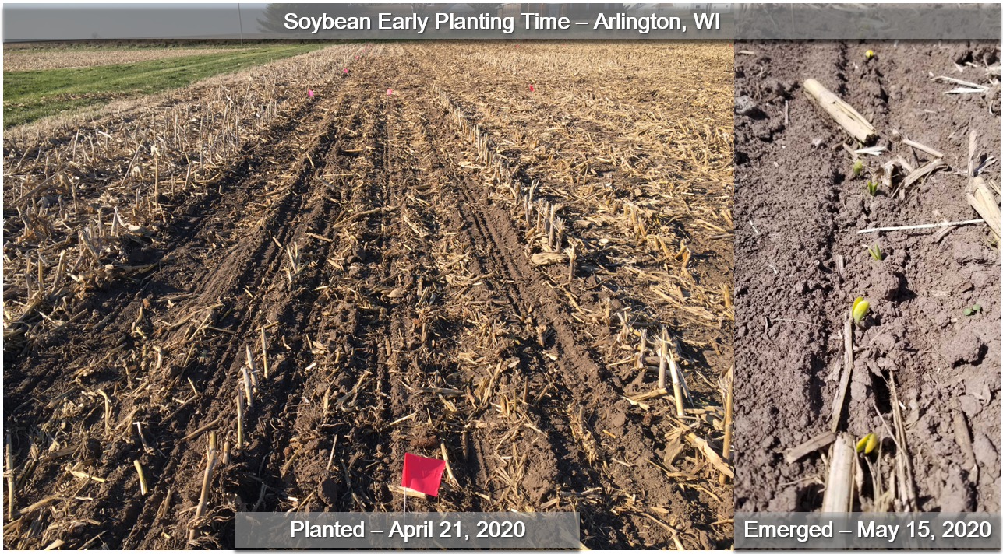

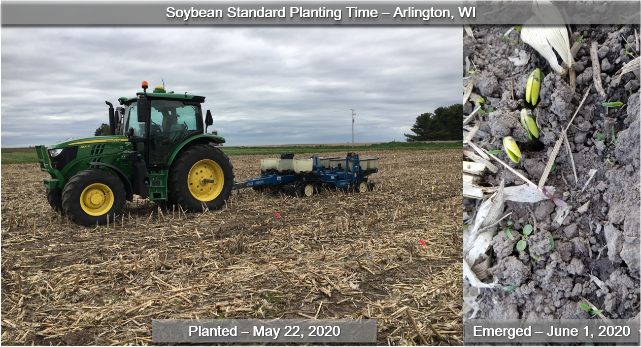

PRE-emergence (PRE) herbicides represent the foundation for weed control in soybean production systems and are recommended for management of weed species with extended emergence window. Additionally, the use of PRE herbicides is considered a crucial component for integrated management of weeds resistant to glyphosate and other POST-emergence herbicides. Some PRE-emergence herbicides persist in the soil to provide several weeks of residual control of small seeded weeds, reducing the reliance on and the need of multiple POST-emergence applications.

PRE-emergence herbicide products available for soybeans consist of either a single active ingredient site of action (SOA), or a premix with multiple active ingredients from multiple SOAs. According to our research (see: “Residual Control of Waterhemp with Pre-emergence Herbicides in Soybean” <https://www.wiscweeds.info/img/2018%202019%20waterhemp%20challenge/PreEmergence_waterhempFINAL.pdf>], PRE-emergence herbicides containing 2 or more effective SOAs provide better control of a wider range of weed species when compared to the use of a single SOA. Using multiple effective SOAs during each pass is also a proactive strategy for herbicide resistance management.

To maximize their residual activity in-season, PRE-emergence herbicides should be sprayed at or shortly after planting. PRE-emergence herbicides need moisture for incorporation and activation in the soil. The flip side is that when PRE-emergence herbicides are sprayed shortly before crop emergence, the risk of crop injury increases, mainly under cool and wet soil conditions during crop emergence. Several effective PRE-emergence herbicides available for soybeans should be applied up to 3 days after planting. For instance, sulfentrazone (Spartan) and flumioxazin (Valor) containing herbicides should be sprayed within 3 days from planting according to their product labels as a strategy to minimize crop injury (e.g., Valor XLT, Enlite, Trivence, Surveil, Fierce, Fierce XLT, Fierce MTZ/Kyber, Afforia, Sonic/Authority First, Authority Assist, Authority MTZ, Authority Supreme, Authority Elite/Broadaxe XC).

Conversely, saflufenacil (Sharpen) and metribuzin (Tricor) allow a little more flexibility and can be sprayed after soybean planting but before crop emergence (Canopy DF, Boundary, Verdict, Zidua PRO). Acetochlor (Warrant), dimethenamid-P (Outlook), S-metolachlor (Dual II Magnum), pyroxasulfone (Zidua), chlorimuron-ethyl (Classic), cloransulam-methyl (FirstRate), imazethapyr (Pursuit), and fomesafen (Flexstar) can be sprayed after soybean emergence (POST application window is herbicide specific) (e.g., Prefix, Warrant Ultra, Anthem Maxx, Perpetuo).

The aforementioned information is intended to address the following questions we have been receiving regarding PRE-emergence herbicide selection in early planted soybeans:

**Can I skip a PRE-emergence application in early planted soybeans and control weeds POST only?** We recommend against that. The use of an effective PRE-emergence herbicide is the foundation for chemical weed control in soybeans. Limited effective POST-emergence herbicide options are available for control of herbicide-resistant weed species such as horseweed, waterhemp and giant ragweed.

**Can I delay my PRE-emergence application on early planted soybeans?** Yes, one could do so by selecting herbicides with soil residual activity that can be sprayed before crop emergence instead of herbicides that must be sprayed within 3 days of crop planting, particularly when the soybean crop is being planted early in the spring, is not expected to emerge for several weeds, and weeds are not actively emerging due to low soil temperatures. Keep in mind that PRE-emergence herbicides are effective if timely incorporated (by light tillage and/or precipitation) and active in top soil solution as weeds germinate and emerge.

With that in mind, we developed the following handy table displaying the application window of commonly used herbicides with soil residual activity in soybean cropping systems: **INCLUDE NICK’s TABLE and LINK to download**

**Additional resources:**

* [**https://www.wiscweeds.info/img/2018%202019%20waterhemp%20challenge/PreEmergence_waterhempFINAL.pdf**](https://www.wiscweeds.info/img/2018%202019%20waterhemp%20challenge/PreEmergence_waterhempFINAL.pdf)
* [**https://www.wiscweeds.info/img/Update%20Series%20Articles/WWRUS%20Article%204_Influence%20of%20PRE%20herbicides%20on%20soybean%20N%20fixation.pdf**](https://www.wiscweeds.info/img/Update%20Series%20Articles/WWRUS%20Article%204_Influence%20of%20PRE%20herbicides%20on%20soybean%20N%20fixation.pdf)
* **2020 research report**